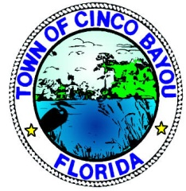
TOWN OF CINCO BAYOU
REQUEST TO SPEAK AT REGULAR COUNCIL MEETING

DATE _______________________________________________________________________________

DATE OF COUNCIL MEETING ________________________________________________________

NAME ______________________________________________________________________________

ORGANIZATION _____________________________________________________________________

ADDRESS __________________________________________________________________________

CITY _____________________________________ ST _____________ ZIP CODE _______________

CONTACT NUMBER _________________________________________________________________

SUBJECT OF REQUEST ______________________________________________________________

SPECIFIC QUESTIONS FOR OR ACTIONS BY THE TOWN COUNCIL
_____________________________________________________________________________________
_____________________________________________________________________________________
_____________________________________________________________________________________
_____________________________________________________________________________________
_____________________________________________________________________________________

REQUEST RECEIVED BY __________________________________ DATE ____________________

